**Phase 1 project:**

**Project Title: Smart Water Foundations**

**Project ID:** proj_223731_Team_5

**College:** Gnanamani College of Technology

**Branch:** B.Tech/Information Techology

**Year:** IIIrd year

**Problem Definition and Design Thinking:**

Smart Water Foundation project leverages the power of the Internet of Things (IoT) and the versatility of the 8051 microcontroller to revolutionize water management systems. With a growing global water crisis, efficient water resource management is imperative. This project integrates sensor networks, data analytics, and automation through the 8051 microcontroller to create a comprehensive solution.

**Problem Definition:**

The 8051 microcontroller serves as the brain of the system, responsible for processing the incoming data, making intelligent decisions, and triggering automated actions. Machine learning algorithms are employed to predict water quality trends and detect anomalies, ensuring early identification of contamination events or leaks. Additionally, the 8051 microcontroller controls valves, pumps, and actuators to optimize water distribution, reducing wastage and energy consumption.

**Design Thinking:**

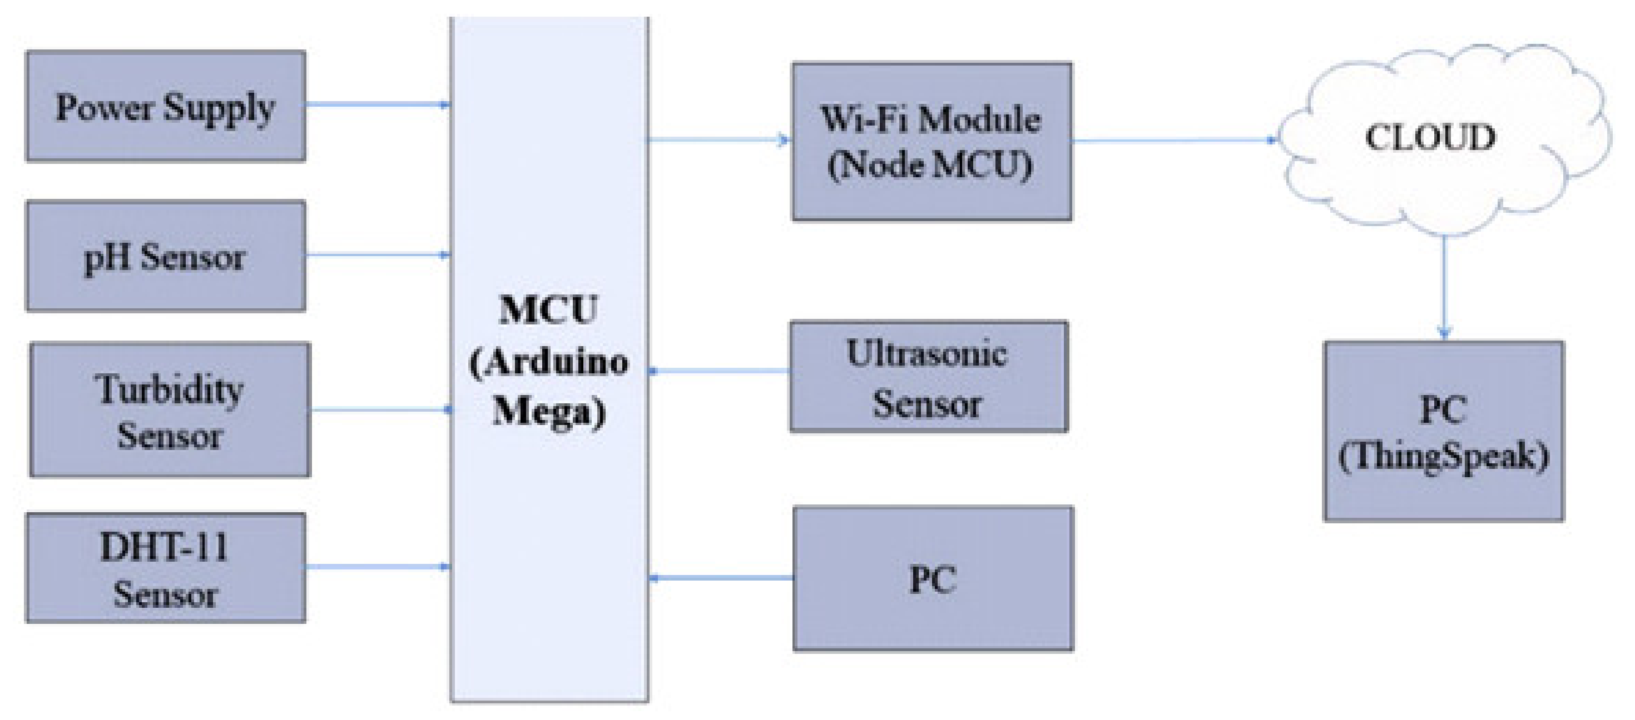

**REQUIREMENTS:**

* 8051 Microcontroller
* IoT Module
* ESP32
* Sensors
* Ultrasonic Sensors
* pH Sensors
* Turbidity Sensors
* Flow Sensors
* Actuators
* Power supply
* Communication
* MQTT
* HTTP
* IoT platform
* AWS IoT
* Azure IoT
* Google Cloud IoT
* User Interface
* Data storage

**Team members:**

* SIVAPRIYAN UV(620821205306)
* MOHANRAJ R(620821205036)
* MATHANRAJ NS (620821205035)
* ARULSURIYAN R (620821205004)
* SIVANESAN S(620821205305)